EHR Configuration

There are three steps to setting up the cloud fax profile within the EHR.
- Create a fax profile
- Add the fax profile tag to the EHR location(s)
- Create the Scheduled tasks

The first task is to create the fax profile; this is done in Admin Module > Site Settings > Fax Settings tab.

When creating a Fax profile for online faxing, the only values that are unique to this setup are the FaxAccountID, FaxAccountPassword and DropDirectoryOut values. Other values are identical to the configuration for on-premises fax servers.

FaxAccountID (this has to be manually added as a key) – this is the username for the Concord fax user
FaxAccountPassword (this has to be manually added as a key) – this is the password for the
Concord fax user
DropDirectoryOut – Gather this from the Client Details Tool. Load the tool, find the client and
open the share. Navigate in the share to HMScan\Fax out and copy the path for this directory.

The image below shows an example of what a cloud fax profile generally looks like.

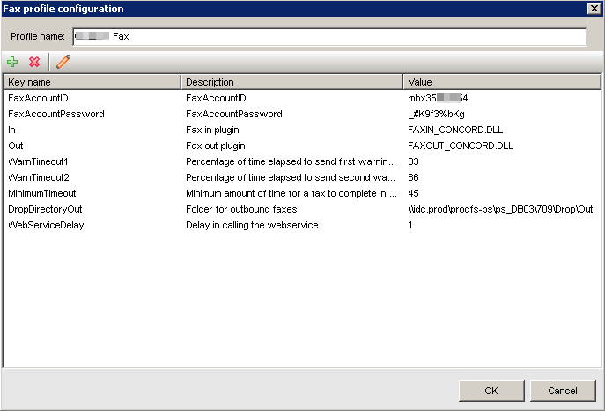

Once the Fax Profile has been saved, the next step is to add the profile to any locations that are
going to use it via Admin Module > Locations. Open the location(s) in question and type the
profile name you created in the Fax Profile box, then save.

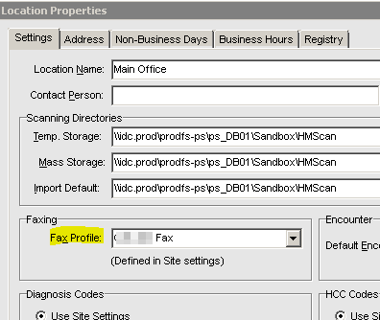

Lastly you’ll need to set scheduled tasks. This will be different depending on environment type.

On-premises –create windows tasks that run faxin.exe and faxout.exe found in the sbin folder on the DB server. Every 5 minutes for each task is normal.

Cloud – create scheduled tasks within Admin Module > Scheduled tasks. There will be 1 for
Inbound Fax and Outbound Fax to configure. Every 5 minutes for each task is normal.

